**Chemistry 12 Equilibrium Test 2018**

**Total Marks____/ 51 Student Name:______________________**

**Multiple Choice Section:( 8 marks, 1 mark each )**

**Question 1:**

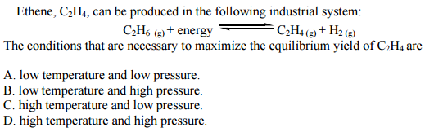

**Question 2:**

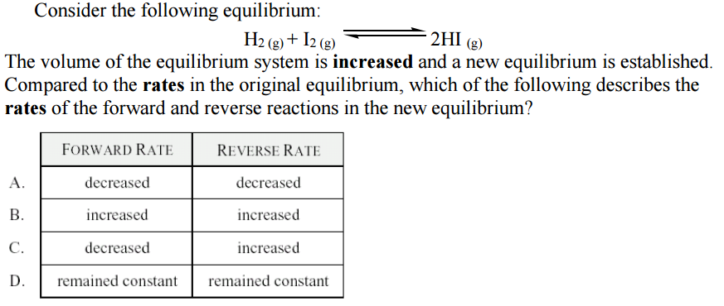

**Question 3:**

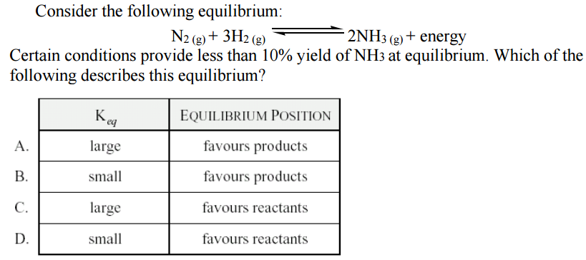

**Question 4:**

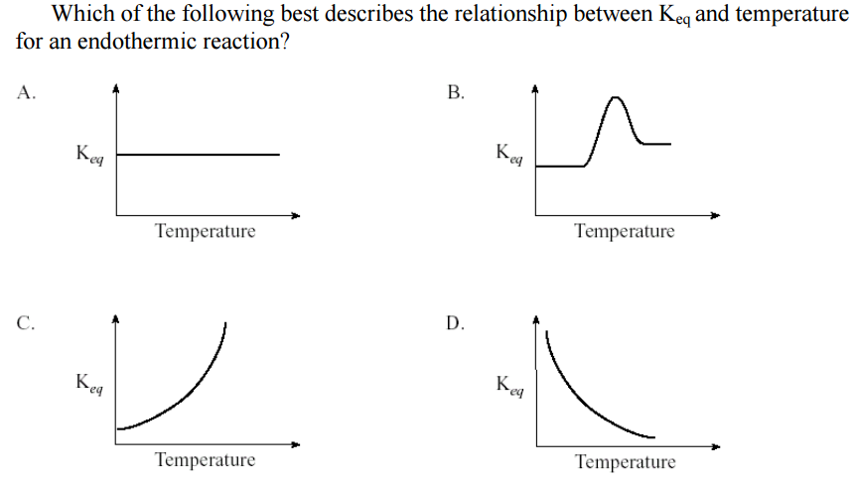

**Question 5:**

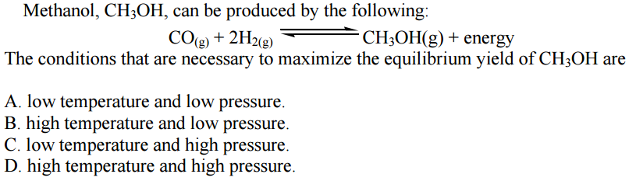

**Question 6:**

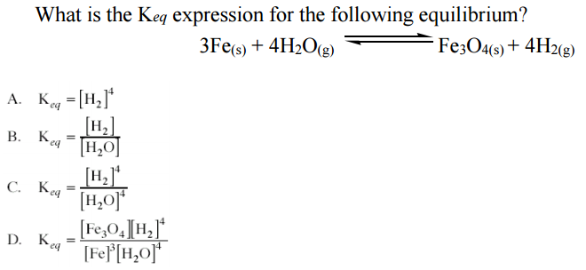

**Question 7:**

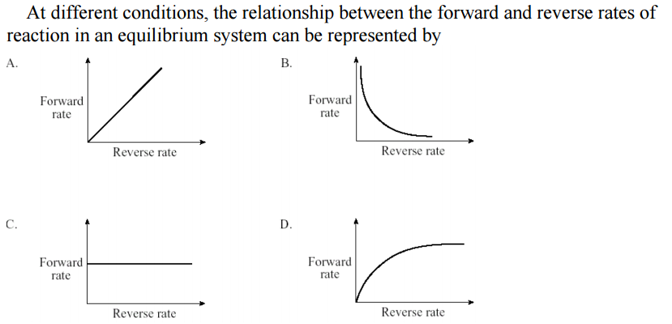

**Question 8:**

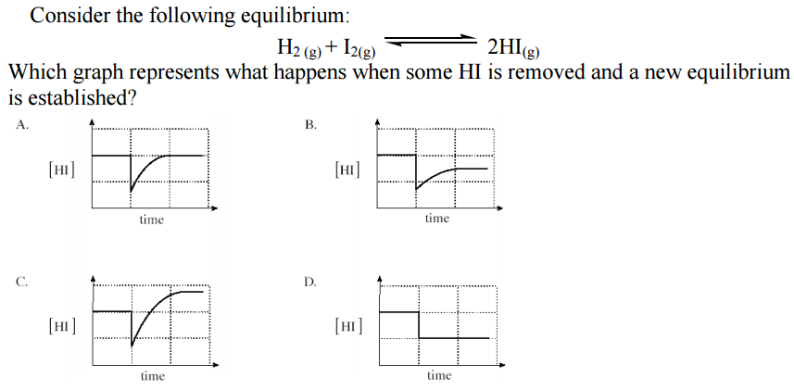

**Short Answer Section: [27 marks]**

**Question 1: [6 marks]**

Ammonia exists in equilibrium with hydrogen and nitrogen as shown by the following exothermic equation.

**N2 (g)    +     3 H2 (g)     ⇌     2 NH3 (g)     ∆H  =  - 92 kJ mol–1**

As they exist in the gaseous state, the relative concentrations can be given in terms of the partial pressure (kPa) of each gas.

Nitrogen, hydrogen and ammonia gases are placed in a rigid container and allowed to reach equilibrium. The graph below shows the partial pressures of the gaseous system initially at equilibrium. After the experiment operates for 4 minutes, a change is imposed upon it.

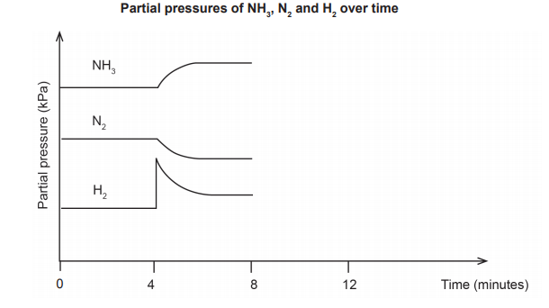

(a) What characteristic of equilibrium is indicated on the graph by the section from 0 to 4 minutes? (1 mark)

**__________________________________________________________________________________**

**__________________________________________________________________________________**

(b) A change was imposed on the system at the 4-minute mark. What imposed change could have produced the results indicated on the graph? (1 mark)

**__________________________________________________________________________________**

(c) The system was suddenly cooled at 8 minutes and then reached equilibrium again at 12 minutes. Using this information, complete the graph above from the 8 to the 12-minute mark. (4 marks)

**Question 2: [8 marks]**

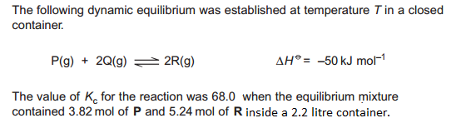

1. Write the Keq equation then solve for the number of moles of Q inside the container when it was at equilibrium. [ **4 marks** ]

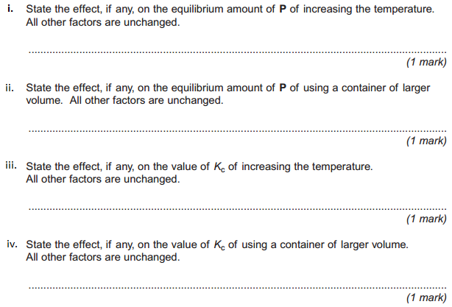**b)**

**Question 3: [13 marks]**

Carbon monoxide, or CO, is an odourless, colourless gas that can cause sudden illness and death. It reacts will oxygen and forms CO2 which is less harmful than CO.

1. (i) On the axes below, draw the forward ( ____ ) and reverse (- - -) reaction rates, starting at the moment the oxygen and carbon monoxide gases begin to react with each other until after equilibrium has been established at time X. Continue the graph until time . (2 marks)

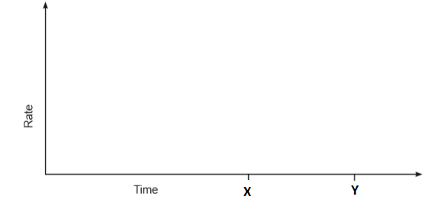

(ii) On the same axes above, draw and label clearly the effect of conducting the same reaction at a lower temperature (3 marks)

1. i. On the axes below, plot separate curves to show how the concentrations of the three gases change with time, starting now the oxygen and carbon monoxide gases begin to react with each other until the system reaches equilibrium at Time T1. Continue the graph from Time T1 to Time T2.

The initial concentrations of oxygen and carbon monoxide are identical. Let’s assume.

Label clearly the line for each gas. (5 marks)

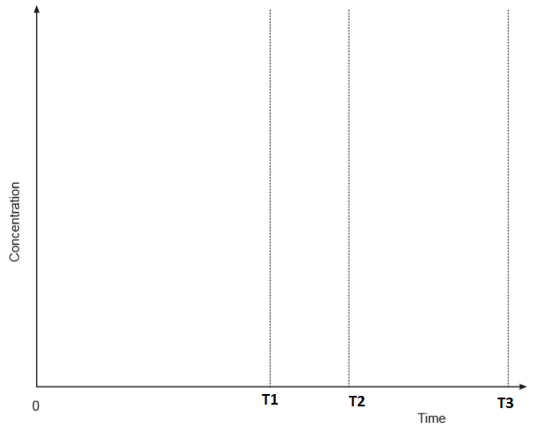

ii. At Time T2 shown on the axis, the reaction vessel is halved in volume, and the system is then again allowed to reach equilibrium at Time T3. On the same graph above, show how the concentrations of the three gases would change in response to the change in volume, from Time T2 until equilibrium is re-established at Time T3. (3 marks)

**Extended Answer (16 marks)**

The two different coloured cobalt(II) complex ions, Co(H2 O)6 2+ and CoCℓ4 2–, exist together in equilibrium in solution in the presence of chloride ions. This is represented by the equation below.

Co(H2 O)6 2+(aq)     +     4 Cℓ– (aq)     ⇌     CoCℓ4 2–(aq)     +     6 H2 O(ℓ)           pink                                                         blue

An experiment is conducted to investigate the effects on the equilibrium position by imposing a series of changes on the system. The shift in equilibrium position can be indicated by any colour change of the solution.

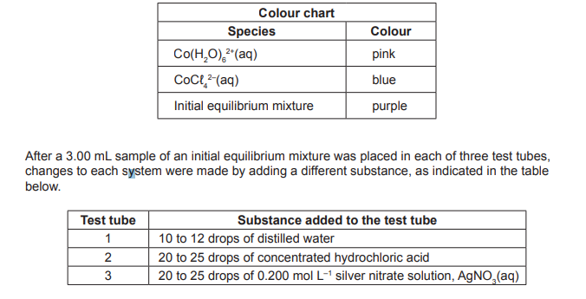

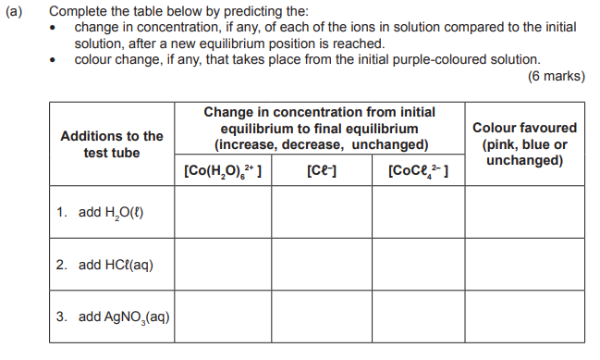

(b) Other than a colour change, what else should be observed in test tube 3? (1 mark)

**__________________________________________________________________________________**

(c) Using Collision Theory, explain your predicted observations when hydrochloric acid is added to test tube 2. (3 marks)

**__________________________________________________________________________________**

**__________________________________________________________________________________**

**__________________________________________________________________________________**

**__________________________________________________________________________________**

**__________________________________________________________________________________**

**__________________________________________________________________________________**

**End of Test**